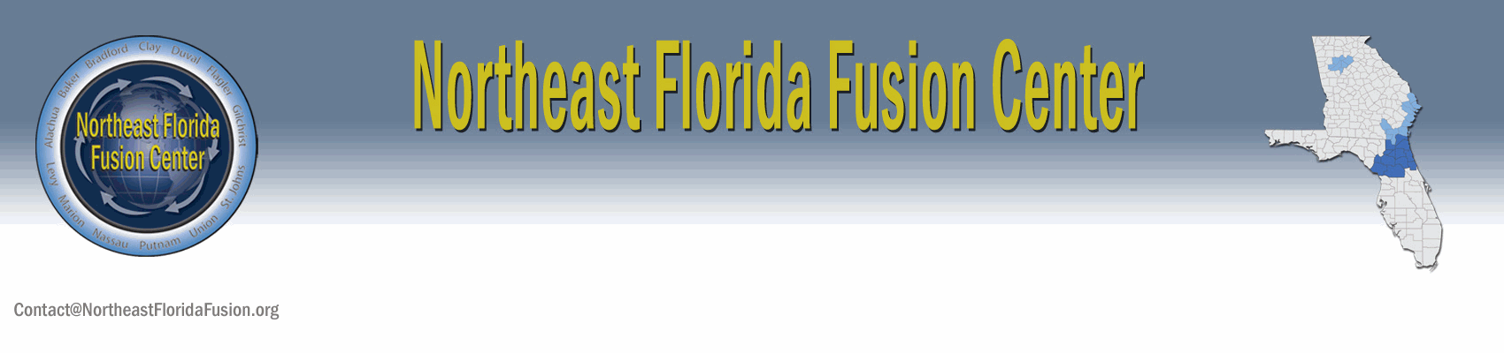
Suspicious Activity Reports (SARs)
For further information on any SAR, including further detail on status or disposition, contact us.
August 27–30, (Current Year)
TOTAL REPORTS: 1

NARRATIVE

On August 25, (of the current year), three men entered the lobby of a casino in Las Vegas, NV at around 1600 hours. They were later identified as:

Noor Aziz Uddin | Sun Kailiang | Adam Gadahn
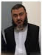 |  | 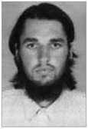

Noor Aziz Uddin: A 50-year-old man wanted for alleged involvement in an international telecommunication scheme that defrauded unsuspecting individuals, companies, and government entities and included large telecom companies in both the United States and abroad. The international scheme involved members of a criminal organization that extended into Pakistan, the Philippines, Saudi Arabia, Switzerland, Spain, Singapore, Italy, and Malaysia, among other nations.

Sun Kailiang: An officer in Unit 61398 of the Third Department of the Chinese People’s Liberation Army (PLA) and wanted for carrying out cyber attacks against six U.S. companies and a nuclear power plant.

Adam Gadahn: A 28-year-old California man wanted on federal charges of treason and providing material support to a terrorist group by making a series of propaganda videotapes for al-Qaeda, including one in which he praised the hijackers involved in the 9/11 attacks and referred to the United States as “enemy soil.” Also known as Azzam the American, Gadahn “gave al-Qaeda aid and comfort . . . with intent to betray the United States.”

The three men went to the casino’s bar and asked the bartender to page the same person. Later it was determined that the person being paged was not real. The three men met each other and made their way over to a table in the corner. The bartender alerted security because it is unusual for three different people to page the same person when they have never met. Furthermore, each person was accompanied by a small cadre of men who seemed to be providing some type of security detail, the bartender said. The casino turned over their video of the situation upon request from government officials. The significance of this event is that until this day, these three men had never been seen together.

The three men were rather loud, the barmaid stated, adding that the man later identified as Noor Aziz Uddin asked several times in broken English, “Are you referring to the dam?” After the meeting broke up, the three men walked out of the casino. At around 1740 hours, the barmaid notified security that the men had left. Security went to the table where the three men had met, and collected all of the glasses to be later used for fingerprint identification, and also gathered pieces of a torn-up napkin. FBI scientists reconstructed the torn napkin, which had the word “dam” on it and a picture of a dam.

An earlier intelligence report dated May 29, (current year) identified Adam Gadahn as the purchaser of large quanitities of fertilizer from a farmer’s supply business located outside of Henderson, NV. This behavior is normal because Gadahn’s family owns and operates several argricultural farms in and around the Las Vegas area. What was unusual about this purchase was how Gadahn paid for the fertilizer. The farm-supply store manager stated that normally, transactions are recorded and then paid off at the end of the month after the customers are billed. For some reason, Gadahn insisted on paying cash this time. This incident, being somewhat suspicious, was reported to the local police department and then forwarded through law-enforcement channels for dissemination.

In 2011, it was reported by U.S. Immigration that Noor Aziz Uddin entered the United States on January 2, 2011. The purpose of his arrival was to visit his sister-in-law in Phoenix, AZ. His current whereabouts are unknown.

